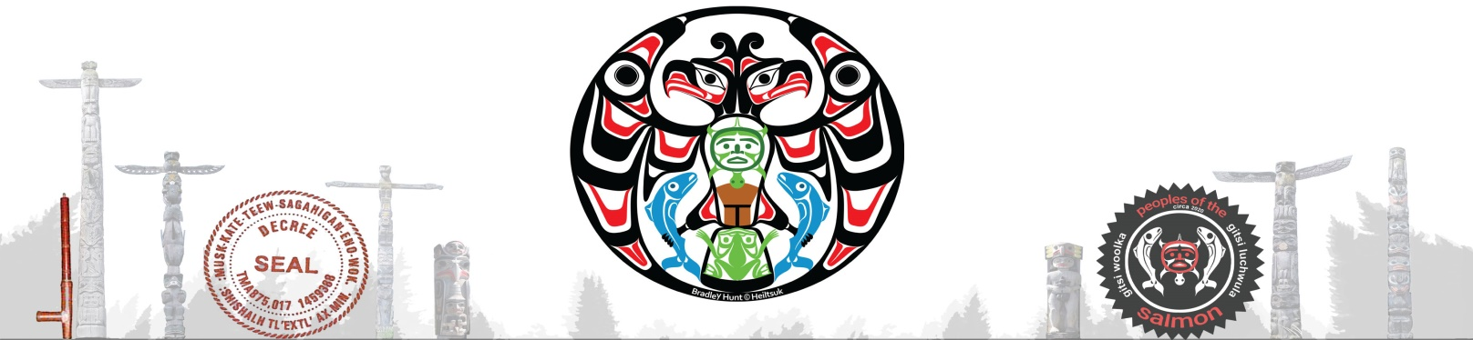

First Law of the Land & Tribunal | Council of 13 | Alliances of Kanat’an | RN 591 243 241 CA
Peoples of the Salmon (Pots) Unsolicited Initiative Proposals

Date:
We welcome initiatives for the Highest Good of all peoples and seven generations. Use this instrument as a guide to filling out your vision, goals, 3 to 5 year plan. Have it ready for further assessment by a Project Coordinator whose job it is to open channels of support. Use it to add yourself as a participant and your project information into the online Directory (coming soon). Follow the template provided below and align with the values and principles of Peoples of the Salmon - www.peoplesofthesalmon.org
- Supports Sovereignty and independence
- Empowers Pots members (away from corporate structures)
- Seeks to improve an identified need of PotS members and all Sovrans.
- Enables mutual agreement in the decision making process with PotS members.
- Represents an ethical approach.
- Respects the integrity of air, land and water
- Aligns with the principles of Natural Law
- Represents a sustainable living resource

Instructions
The template is provided as a reference only. Not all sections will be relevant for your organization and you may need to modify it to respond to your needs.
Write simply and concisely. Consider using bullets instead of paragraphs.
Avoid repetition.
Your business plan is not a static document. You will enter it as an active Project Listing in the Directory which will require your regular Review and Updates to reflect changing conditions.
Email to info@peoplesofthesalmon.org State “Project Proposal” in the Subject line of your email. Feedback is expected within two to four weeks. Proposals will be reviewed by the Tribunal, Headsmen and select Wolverines.
Thank you for sharing your knowledge and desire to be of service.
PROJECT PROPOSAL TEMPLATE
PROJECT PROPOSAL TITLE
PROJECT SUMMARY SHEET:

Project Title:
Proposal Guiding Principles: (based on Original Peoples Law of the Land)
Project Period: Estimated 5-Year Budget:
Annual Operating Budget:
Project Participants:
Proposal presented to:
Proposal presented by:
Current Operation:
Applicant’s Contact Info:
Website URL:
Project Leader(s):

Project Title

Introduction: Background information - purpose, facts, needs – expected results / intended benefits.
Opportunity: What is the current status/state, evidence, facts, remedy
Objective(s) and Goals: Anticipated outcomes and goal audience
Development: Status, Plan, Partners, Outcomes, Products and/or Services. (Be specific)
Background Wisdom & Knowledge: Resources
Conclusion:
Budget & Timeline: Financials and Funding – Comprehensive Budget
Operating Budget: (1 to 10 years)
Project Team: (Board Members – Strategic Team – Key Players)

Non-domestic: [6242 Sunshine Coast Highway, Sechelt, British Columbia, Kanat’an V7Z 1M0]
All trespassers/unauthorized users engaging without consent are subject to
True Bill Liability of $1 billion USN (equivalent Gold bullion). Registered notices have been served
All Rights Reserved.: Claim of Rights.: Without Prejudice. Copyright © 2023 Peoples of the Salmon

